**Ambavaram Tirumala Kondareddy(192210642)**

**8. Create an infographic in Figma explaining the concept of Public Land Mobile Network (PLMN).**

**Aim: To create an infographic in Figma explaining the concept of Public Land Mobile Network (PLMN).**

**Procedure:**

**1. Open Figma**

**2. Create a new file**

**3. Select the Frames**

**4. Fill in the content that is required for presentation**

**5. Design Visual Elements**

**6. Make it Interactive**

**7. Add Annotations and Explanations**

**8. Incorporate Multimedia**

**9. Storyboard Animation**

**10. Review and edit the Prototype**

**11. Save and Share**

**Design:**

**Prototype:**

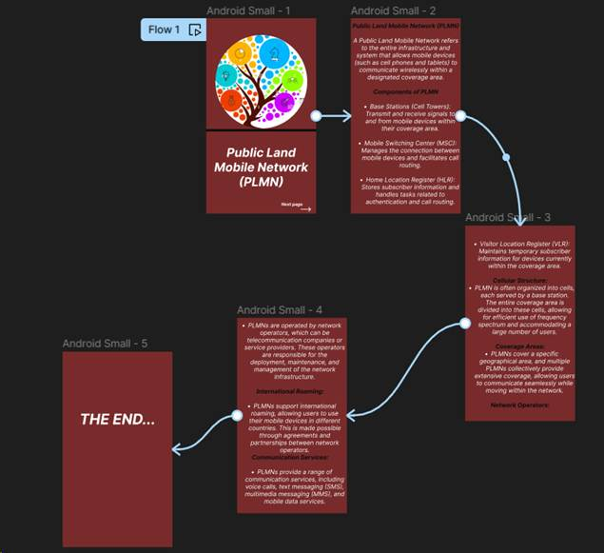

**Result:**

Hence created an infographic in Figma explaining the concept of Public Land Mobile Network (PLMN).